Database and Tables creation:

🡪DB name is IMDB create table using my sql  
  
CREATE TABLE Genre (

genre_id INT AUTO_INCREMENT PRIMARY KEY,

genre_name VARCHAR(50) NOT NULL

);

CREATE TABLE Movie (

movie_id INT AUTO_INCREMENT PRIMARY KEY,

movie_title VARCHAR(100) NOT NULL,

release_year YEAR,

duration_minutes INT,

-- Other attributes of movie like director, producer, etc. can be added here

);

CREATE TABLE Movie_Genre (

movie_id INT,

genre_id INT,

PRIMARY KEY (movie_id, genre_id),

FOREIGN KEY (movie_id) REFERENCES Movie(movie_id),

FOREIGN KEY (genre_id) REFERENCES Genre(genre_id)

);

CREATE TABLE Media (

media_id INT AUTO_INCREMENT PRIMARY KEY,

media_type ENUM('video', 'image') NOT NULL,

media_url VARCHAR(255) NOT NULL,

movie_id INT,

FOREIGN KEY (movie_id) REFERENCES Movie(movie_id)

);

CREATE TABLE Artist (

artist_id INT AUTO_INCREMENT PRIMARY KEY,

artist_name VARCHAR(100) NOT NULL

-- Other artist details like birth date, nationality, etc. can be added here

);

CREATE TABLE Artist_Skill (

artist_id INT,

skill VARCHAR(50) NOT NULL,

PRIMARY KEY (artist_id, skill),

FOREIGN KEY (artist_id) REFERENCES Artist(artist_id)

);

CREATE TABLE Movie_Artist (

movie_id INT,

artist_id INT,

role VARCHAR(50) NOT NULL,

PRIMARY KEY (movie_id, artist_id),

FOREIGN KEY (movie_id) REFERENCES Movie(movie_id),

FOREIGN KEY (artist_id) REFERENCES Artist(artist_id)

);

CREATE TABLE User (

user_id INT AUTO_INCREMENT PRIMARY KEY,

username VARCHAR(50) NOT NULL,

-- Other user details like email, password, etc. can be added here

);

CREATE TABLE Review (

review_id INT AUTO_INCREMENT PRIMARY KEY,

movie_id INT,

user_id INT,

review_text TEXT,

rating DECIMAL(3, 1), -- Assuming rating out of 10

review_date DATE,

FOREIGN KEY (movie_id) REFERENCES Movie(movie_id),

FOREIGN KEY (user_id) REFERENCES User(user_id)

);

1.Movie should have multiple media(video or image)

SELECT movie.movie_id, movie.movie_name

FROM movie

JOIN media ON movie.movie_id = media.movie_id

WHERE media.media_type IN ('video', 'image')

GROUP BY movie.movie_id, movie.movie_name

HAVING COUNT(DISTINCT media.media_id) > 1;

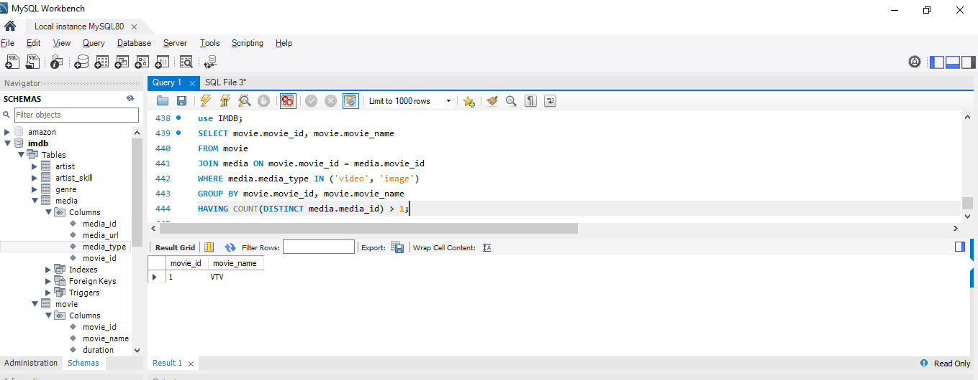

2.Movie can belongs to multiple genre

SELECT movie.movie_id,movie.movie_name,group_concat(distinct genre.genre_name) as genres

from movie

JOIN media on movie.movie_id=media.movie_id

JOIN movie_genre on movie.movie_id=movie_genre.movie_id

join genre on movie_genre.genre_id=genre.genre_id

where media.media_type in('video','image')

group by movie.movie_id,movie.movie_name

having count(distinct media.media_id)>1;

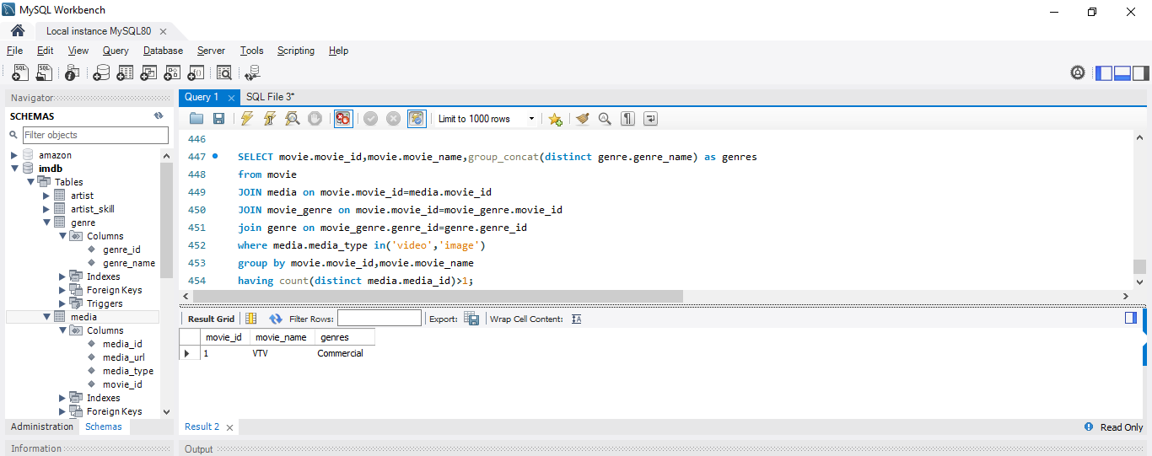

3.Movie can have multiple reviews and Review can belongs to a user

SELECT movie.movie_id, movie.movie_name,

GROUP_CONCAT(DISTINCT genre.genre_name) AS genres,

COUNT(DISTINCT media.media_id) AS media_count,

COUNT(DISTINCT review.review_id) AS review_count,

GROUP_CONCAT(DISTINCT CONCAT(user.user_name) ORDER BY review.review_id SEPARATOR ', ') AS reviewers

FROM movie

JOIN media ON movie.movie_id = media.movie_id

JOIN movie_genre ON movie.movie_id = movie_genre.movie_id

JOIN genre ON movie_genre.genre_id = genre.genre_id

LEFT JOIN review ON movie.movie_id = review.movie_id

LEFT JOIN user ON review.user_id = user.user_id

WHERE media.media_type IN ('video', 'image')

GROUP BY movie.movie_id, movie.movie_name

HAVING media_count > 1;

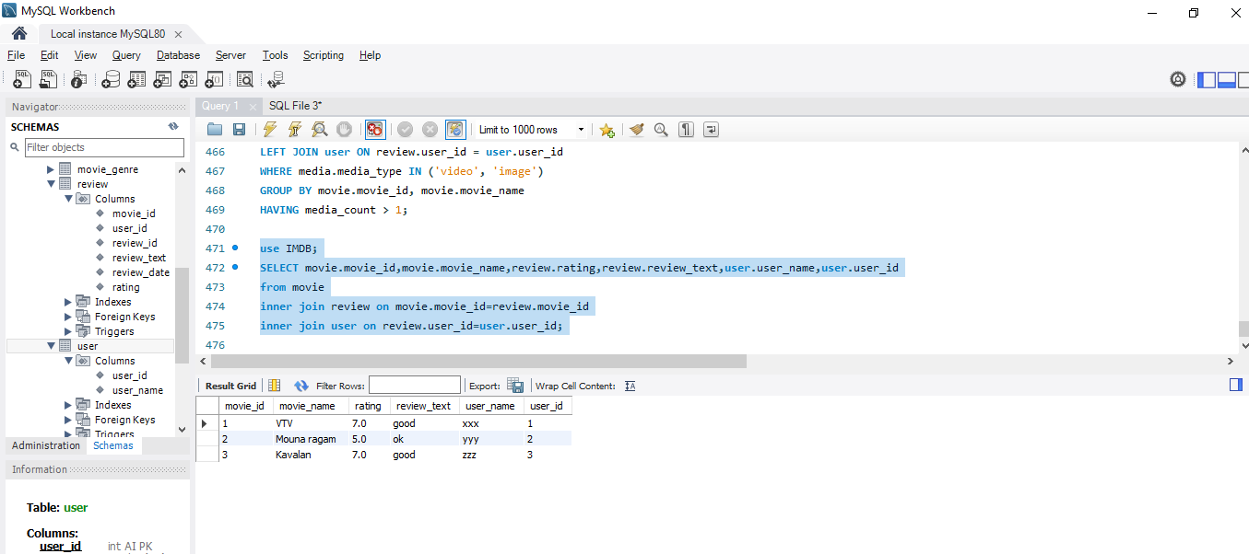

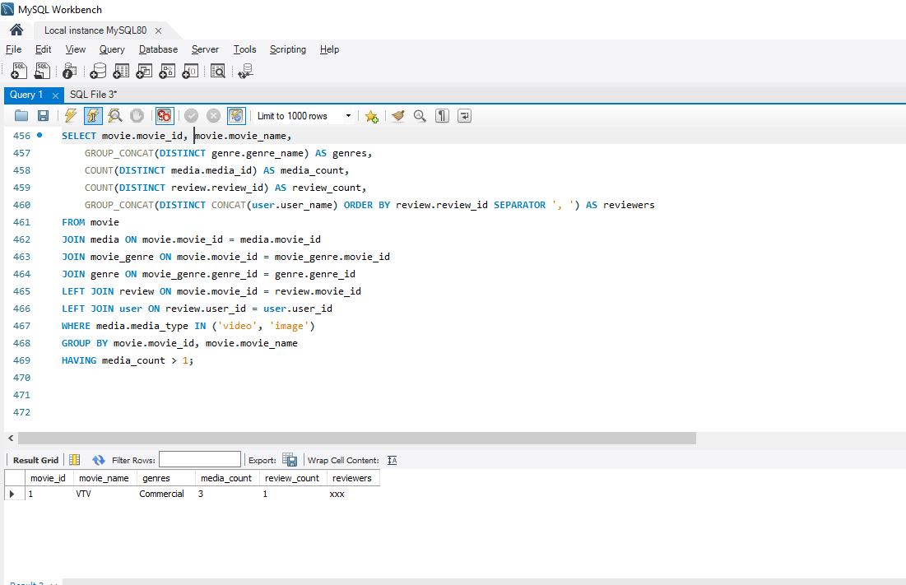

4.Artist can have multiple skills

SELECT artist.artist_name,artist_skill.skill

FROM artist

INNER JOIN artist_skill on artist.artist_id=artist_skill.artist_id;

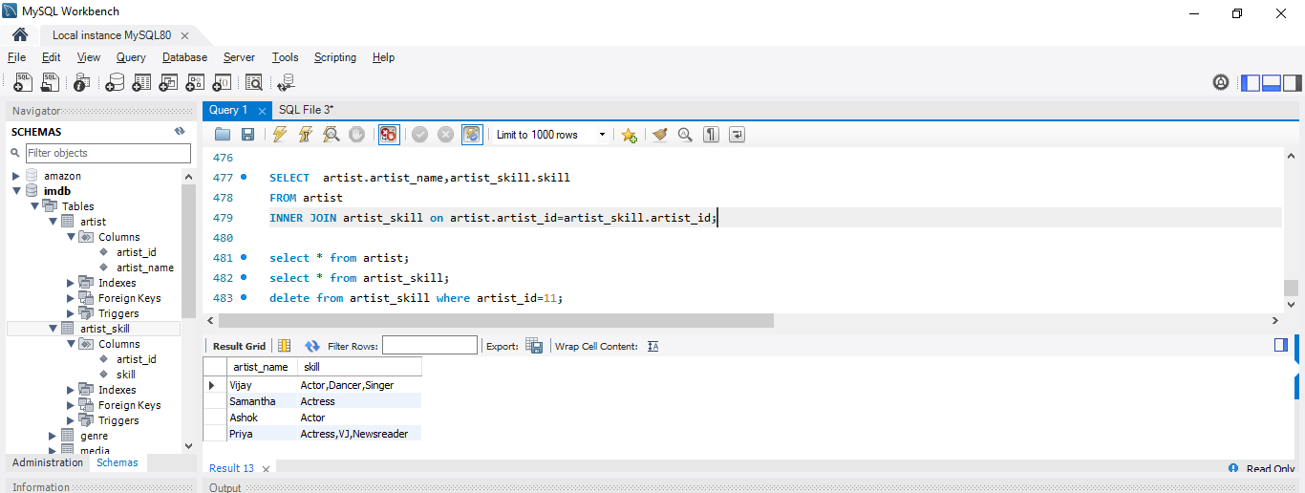

5.Artist can perform multiple role in a single flim

SELECT movie.movie_id,movie.movie_name,movie_artist.role

from movie

join movie_artist on movie.movie_id=movie_artist.movie_id;

